

INDEPENDENT UNIVERSITY, BANGLADESH

Term Paper COURSE: System Analysis and Design

SECTION: 02

|  |
| --- |
| SUBMITTED BY:    SYED ALI REDWANUL HAIDER  ID: 1930580    ADIBA HAQUE  ID: 1931051  MD RAKIBUL HASAN  ID: 1730174    SUBMITTED TO:  Sabrina Alam    DATE OF SUBMISSION:  21/08/2022 |

Section 1:

1. Introduction

2. History leading to project request

3. Identify Problem, opportunity

4. Project goal and objectives

Section 2:

5. Product Description

6. System Context diagram

7. Hardware detail (Include Rich Picture)

8. Key Technical Features of Software

Section 3:

9. Information Gathering methods (At least three methods)

10. Major functionalities offered by the system

11. Use Case Diagram

12. Normal Scenarios (At least 2)

13. Alternate Scenarios (At least 2)

14. Functional Requirements

15. Non-Functional Requirements (At least 5)

Section 4:

16. Entity Relationship Diagram

17. Logical Data Flow diagram

18. Physical Data Flow diagram

19. Activity diagrams

20. Sequence diagrams

21. Communication diagrams

22. Class diagrams

23. State-chart diagrams.

24. CRUD matrix

Section 5:

25. Structure English pseudo code for the system

26. Prototype the user interface



Enclave Citizen Service System

Section 1:

1. Introduction

Enclave areas are the detached areas where communication with the central government and the people living within face problems to have official communications for their citizen services. There might be many ways that the government is securing and giving them facilities physically but in modern technology we are living, the deficiencies could be solved with a simple website where the citizens and administrators can communicate inorder to resolve their problems. Often it takes days to let a citizen put in an application due to the buffer and physical barrier they have between the country’s administration and enclave area. The aim of this project is to develop a system that would replace the current system of physical workflow while providing an online reservation system and need based application or feedback. It will be beneficial for the people of the government department working on it and citizens living within that area. Eventually the system can have further improvements for liaison services, local ngo’s, or even bgb can be involved with the system. Also, for busy executives who are always on the go our system comes with remote access features which will allow us to always manage the workforce anytime. These system will ultimately be able to manage resources better

2. History leading to project request

An enclave country is a country whose territory is completely surrounded by the territory of

One other country. Throughout the world there has been countless cases of enclave portion of a country. So the citizens are not properly served the rights of citizen and due to no ground

Connection with the mainland the citizen suffered to get any chance to request for their basic needs which a country offers. Often the validity of a citizen is hard to examine because operation of investigating the background of the citizen gets hard for officers staying in the mainland. Often when the trapped citizen needs to consult with the main land the citizen needs to take a visa to pass the country which is enclaves the portion and residents could neither enter the host country or their mainland legally. Without valid identity of the citizen they lived in the portion without any proper citizenship rights such as basic education, administrative, security and health or postal services. The difficulties of the enclave citizens of their life. In order to resolve this buffer between the mainland and the citizens of enclave portion of the country the project is proposed for solving basic services that will somehow create as formal communication between the mainland administrative and the citizens living within the enclave country.

3. Identify Problem, opportunity

|  |  |  |
| --- | --- | --- |
| **PROBLEMS** | **SOLUTION** | **OPPORTUNITY** |
| People in the first place who couldn’t enlist themselves as citizen of the country in the enclave area are not able to enlist until another team visit to tally them and enlist the people as citizen. For this vary reason the person is abandoned to receive all the services a citizen needs from the mainland area. | Enlisting them as citizen when the person registers himself providing all the required information in order to receive citizenship | Our system provides an opportunity where the user can apply for citizenship as registering into the app. The user will be asked to provide necessary details in order to avail the citizenship of that country and the administrative will set the information which the user shall provide, the user will be receiving and confirmation mail when the registration is successful or he might receive a mail where the administrative will mention the to provide the further papers and data of information for successfully registering. |
| Citizen in the enclave area requires Need Based Aids Health, Food & Accommodation services from government in order to survive. The supplies which are required are provided by the government and due to no ground contact with the administrative the citizen suffers to reach for requesting their need to administrative. | Accounting the request for any individual Citizen officially and taking application to the administrative for any significant service for that Citizen. | The automated system will consist an option where the Citizen will be asked to request for any Need Based Aids, Health, and Food & Accommodation services. The will be given a brief list of necessary options. As example for Food there will be given a list of necessary food where the user can select the item which he will be needing. |
| Citizens having wrong information listed in their details faces problems to rectify the details of their profile. | The information can be edited and the correct information is replaced in the table | Our system has an option where the citizen can edit their information by selecting edit option and the citizen will be able to replace the correct piece of information through the system. |
| Citizen in need of consultancy living within the enclave area suffers to communicate with the administrative verbally | Citizen shall be given a procedure to connect with the administrative for face to face communication | The user will get an opportunity to get an select a slot for appointment where the user can fix time according to the slot and even they will be able to delete the appointment if the citizen wants to. The Citizen will receive en email each time the Citizen selects appointment or delete it. |
| Citizens often complains about the services they receive from the administrative and the service of citizen from a country | The Citizen shall be given a chance to share their thoughts about the service | Citizen will be able to provide a feedback from the given option within the system. The system will have a portal where it will ask the user the feedback as complain from the citizen and administrative will be able to see this. |

4. Project goal and objectives

The main goal of this project is to develop a process where the people living in the enclave area can communicate with the country's administration and they can ask for accommodation or need based application and even can set reservations for appointments.

The objective of the online Enclave Citizen Service System project is to design a software to fully function the issue of communication with the citizen and administrative.

Citizen Management in Enclave Area

- Admin Login in their portal

- Citizen Login or Registers

- Citizen views Information

- Edit Citizen Information

- Citizen Applies for Need Based Aids Health, Food &amp; Accommodation

- Appointment Booking

- Appointment slot selection through online on selected date and time

- Appointment Cancellation

- Confirmation Email

- Feedback

Section 2:

5. Product Description

The Proposed project is a smart appointment and Aid Request booking system that provide

citizens within the enclave area an easy way to request for Need Based Aids Health, Food &amp;

Accommodation and Appointment management with the administration with the mainland.

This is a web based application that overcomes the issue of managing the demands and requirement request of a citizen. Often it gets tedious for the government officers and citizens to establish proper communication between them. Hence the project offers an effective solution where the user can view various options such as registering itself with the administration, applying for need based request, or editing citizen information and many more which is based on simple rights for citizens. This system also allows to allocate an appointment time and cancel it from the designated slot it selected in the first place.

6. System Context diagram

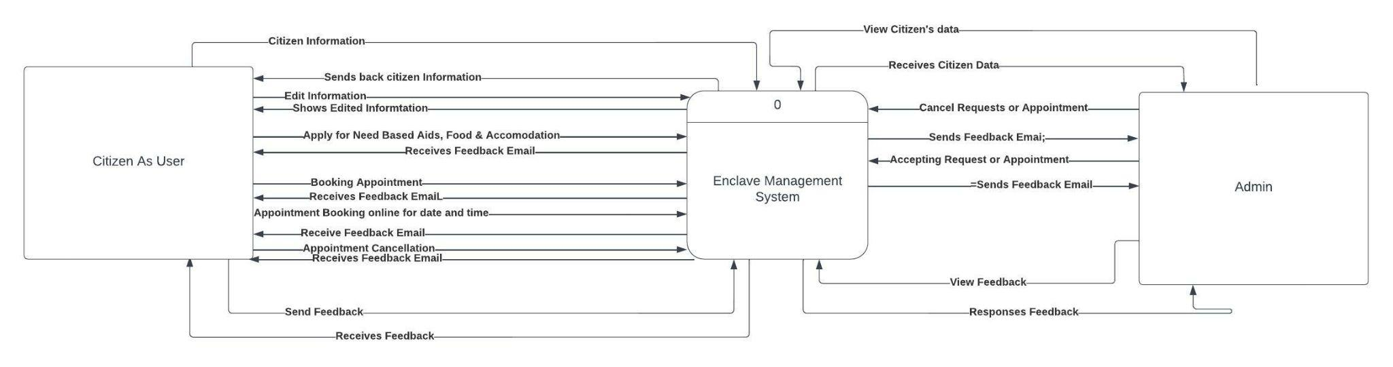

7. Hardware detail (Include Rich Picture)

**Software Requirements:**

- Windows XP, Windows 7(Ultimate, Enterprise) or more Updated

- SQL 2010 or More Updated

- Visual Studio 2019 or more updated

**Recommended Hardware Components:**

-Processor i3 intel

- HardDisk 6GB

- Memory 1GB RAM

8. Key Technical Features of Software

- Completing the Functionalities

- User Friendly

- Efficient

- Highly Secured

- Reliable and Maintainable

- Portable and inheritable

Section 3:

9. Information Gathering methods (At least three methods)

**Documentation Review**

We have analyzed the current system of enclave management between the citizens and administrative employee working for the for government to communicate with the enclave citizens analyzing the annual reports, monthly reports, progress reports, citizen documents, citizen and rules policy and procedure, records, forms, and the database etc. the thorough investigation of this provided us a brief ideas about the current system procedure and operations between the citizen and administrative.

**Personal Interview**

We ran an interview of administrative and citizens to be acknowledged about their key roles within the operations and the process they follow to manage the current system to run their procedure and their desire expectation of out from the **Enclave Citizen Service System** and how the system should follow the role to complete their goals

**Observations**

We have visited the office handling the official operation and the enclave area to view their roles physically to gather information and observe the actual day-to-day scenarios and how chaotic the environment actually is, and the status of people living, how many people needs government facilities and the time process it takes for a citizen within that area to communicate with the administrative employees and how requests are accepted and verified.

10. Major functionalities offered by the system

**Stakeholders**

**User**

- Citizen Information

- Edit Information

- Apply for Need Based Aids Health, Food & Accommodation

- Appointment booking

- Appointment booking online for date and time

- Appointment Cancellation

-Send Feedback

**Admin**

- View User Data

- Cancellation or request or appointment

- Accepting request or appointment

- Send feedback Email

- Feedback view and reply

11. Use Case Diagram

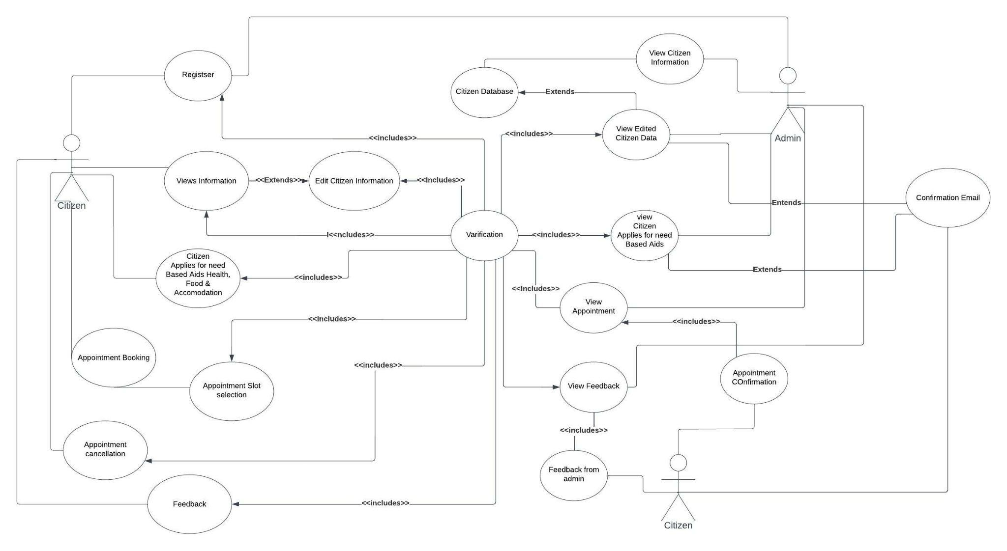

12. Normal Scenarios (At least 2)

|  |
| --- |
| **Use case name:** Edit Citizen information |
| **Area:** Enclave Citizen Service System |
| **Actor(s):** Citizen |
| **Description:** Allow the citizen to edit information of itself using a secure website or app |
| **Triggering Event:** Citizen makes a request to edit its information clicking on edit button which lets the user to retype the information |
| **Trigger Type:** External |
| |  |  | | --- | --- | | **Steps Performed (Main Path)** | **Information for steps** | | 1. Citizen Logins to the secure web server. | Citizen NID, Password | | 2. Citizen Record is read and password is verified. | Citizen Record, Citizen NID, Password | | 3. Dashboards show options to citizen and the Citizen clicks on “Citizen Information” button. | Citizen Record | | 4. Interface shows Citizen’s information and the Citizen clicks on edit button to edit information. | Citizen Record | | 5. Edit options lets the Citizen re-type. After re-typing the Citizen have to click save button. | Citizen Record table, New Citizen Record table | | 6. Conformation card pops-up. Citizen clicks on confirm | Confirmation card | | 7. Edit Request is sent to admin and the user and the user is taken to Citizen information page. Request pending stays on top | Citizen Record Table | | 8. Confirmation is sent to Citizen’s notification when admin accepts the request. | Confirmation Page | |
| **Preconditions:** Citizen is registered on the Enclave Citizen Service System |
| **Post conditions:** Citizen has successfully edited the information |
| **Assumptions:** The citizen has a browser or the app |
| **Requirements Met:** Allow the Citizen to be able to Edit the information using secure web site |
| **Outstanding Issues:** Should the editing character’s to be controlled? |
| **Priority:** High |
| **Risk:** Medium |

|  |
| --- |
| **Use case name:** Appointment Booking |
| **Area:** Enclave Citizen Service System |
| **Actor(s):** Citizen |
| **Description:** Allow Citizen to book a slot for appointment with the administrative |
| **Triggering Event:** Citizen uses a website to book a slot for appointment |
| **Trigger Type:** External |
| |  |  | | --- | --- | | **Steps Performed (Main Path)** | **Information for steps** | | 1. Citizen Logins to the secure web server. |  | | 2. Citizen Record is read and password is verified. |  | | 3. Dashboards show options to citizen and the Citizen clicks on “Appointment Booking” button. |  | | 4. The Citizen choses free slots from the interface shown and clicks on “book” |  | | 5. Confirm slot card appears and the Citizen clicks on the confirm button |  | | 6. The Citizen is taken to Dashboard with a “Pending Request” written on top of Appointment Booking page |  | | 7. Confirmation is sent to Citizen’s notification when admin accepts the request. |  | |
| **Preconditions:** Citizen is registered on Enclave Citizen Service System |
| **Post conditions:** Citizen has successfully booked slot for appointment |
| **Assumptions:** Citizen has browser |
| **Requirements Met:** Allow the Citizen to be able to book slots for appointment using a secure website |
| **Outstanding Issues:** Should the time of slot booking be controlled? |
| **Priority:** Medium |
| **Risk: Medium** |

13. Alternate Scenarios (At least 2)

|  |
| --- |
| **Use case name:** Edit Citizen information |
| **Area:** Enclave Citizen Service System |
| **Actor(s):** Citizen |
| **Description:** Allow the citizen to edit information of itself using a secure website or app |
| **Triggering Event:** Citizen makes a request to edit its information clicking on edit button which lets the user to retype the information |
| **Trigger Type:** External |
| |  |  | | --- | --- | | **Steps Performed (Main Path)** | **Information for steps** | | 1. Citizen Logins to the secure web server. | Citizen NID, Password | | 2. Citizen Record is read and password is verified. | Citizen Record, Citizen NID, Password | | 3. Dashboards show Notification about the denied edit request and Citizen Clicks on | Citizen Record | | 4. Interface shows Citizen’s information and the rejected information are marked as red. The Citizen clicks on edit button to edit information again. | Citizen Record | | 5. Edit options lets the Citizen re-type. After re-typing the Citizen have to click save button. | Citizen Record table, New Citizen Record table | | 6. Conformation card pops-up. Citizen clicks on confirm | Confirmation card | | 7. Edit Request is sent to admin and the user and the user is taken to Citizen information page. Request pending stays on top | Citizen Record Table | | 8. Confirmation is sent to Citizen’s notification when admin accepts the request. | Confirmation Page | |
| **Preconditions:** Citizen is registered on the Enclave Citizen Service System |
| **Post conditions:** Citizen has successfully edited the information |
| **Assumptions:** The citizen has a browser or the app |
| **Requirements Met:** Allow the Citizen to be able to Edit the information using secure web site |
| **Outstanding Issues:** Should the editing character’s to be controlled? |
| **Priority:** High |
| **Risk:** Medium |

|  |
| --- |
| **Use case name:** Appointment Booking |
| **Area:** Enclave Citizen Service System |
| **Actor(s):** Citizen |
| **Description:** Allow Citizen to book a slot for appointment with the administrative |
| **Triggering Event:** Citizen uses a website to book a slot for appointment |
| **Trigger Type:** External |
| |  |  | | --- | --- | | **Steps Performed (Main Path)** | **Information for steps** | | 1. Citizen Logins to the secure web server. |  | | 2. Citizen Record is read and password is verified. |  | | 3. Dashboards shows notification to book appointment again. The Citizen clicks “Appointment Booking” button. |  | | 4. The Citizen choses free slots from the interface shown and clicks on “book” |  | | 5. Confirm slot card appears and the Citizen clicks on the confirm button |  | | 6. The Citizen is taken to Dashboard with a “Pending Request” written on top of Appointment Booking page |  | | 7. Confirmation is sent to Citizen’s notification when admin accepts the request. |  | |
| **Preconditions:** Citizen is registered on Enclave Citizen Service System |
| **Post conditions:** Citizen has successfully booked slot for appointment |
| **Assumptions:** Citizen has browser |
| **Requirements Met:** Allow the Citizen to be able to book slots for appointment using a secure website |
| **Outstanding Issues:** Should the time of slot booking be controlled? |
| **Priority:** Medium |
| **Risk: Medium** |

14. Functional Requirements

-Admin can see and reject/accept Edit Citizen Information

-Citizen can register for availing facilities

-Citizen can view and edit information

-Citizen can apply for “need Based Aids Health, Food & Accommodation “

-Citizen can Book and Cancel Appointment

-Citizen can provide feedback

-Admin can see “need Based Aids Health, Food & Accommodation “and see confirmation Email.

-Admin can see “Appointment Bookinf “and seed confirmation Email.

-Admin can see and send response to Citizen’s Feedback

15. Non-Functional Requirements (At least 5)

Security – The system should not leave any cookies on the customer’s computer containing the user’s password. The system’s back-end server shall only be accessible to authenticated management

Performance – The response time of the website should be minimal and should be able to handle heavy traffic

Maintainability – A RDBMS is used for maintaining the database and the software design is being done with modularity in mind so that maintainability can be done efficiently

Usability - The website’s interface must be user-friendly and easy to use

Supportability – The code and supporting modules of the system will be well documented and easy to understand

**Section 4:**

16. Entity Relationship Diagram

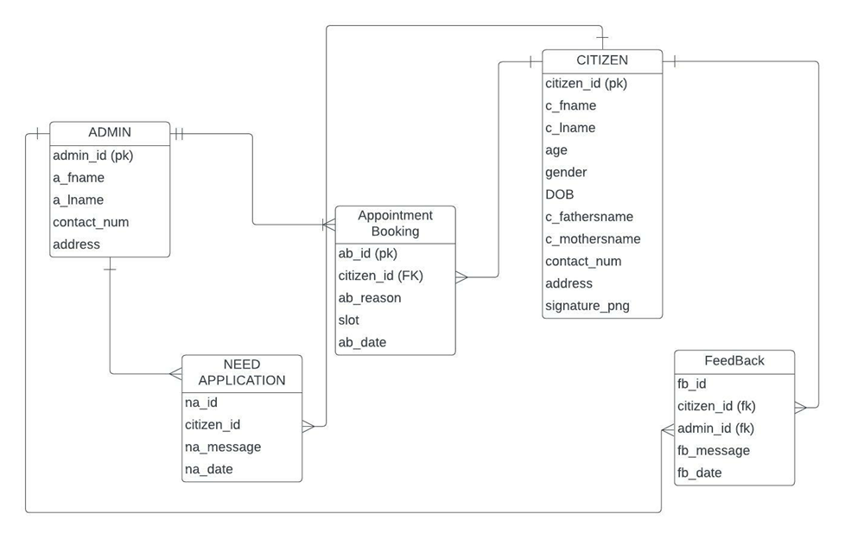

17. Logical Data Flow diagram

Logical Data Flow Diagram of Citizen booking an Appointment –

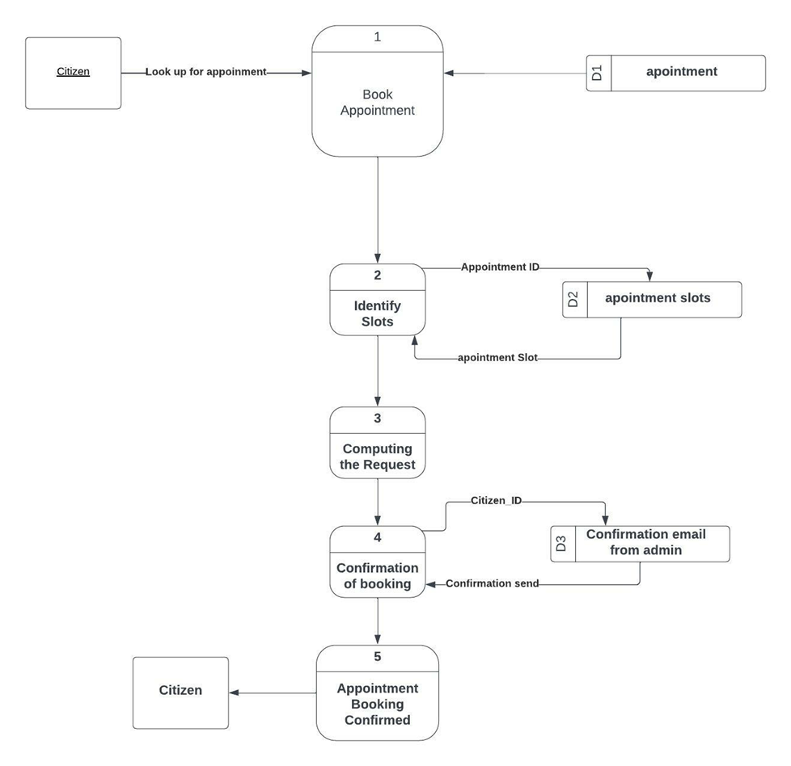

Logical Data Flow Diagram of Citizen canceling an Appointment –

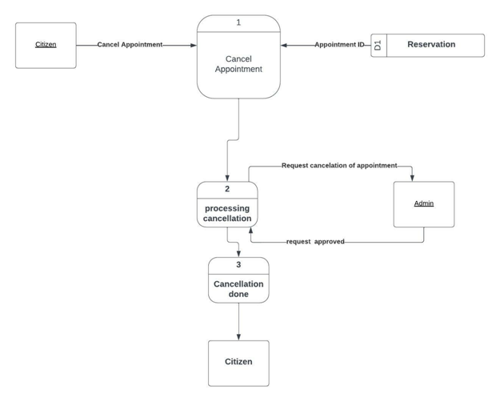

18. Physical Data Flow diagram

Physical Data Flow Diagram of Citizen booking a reservation –

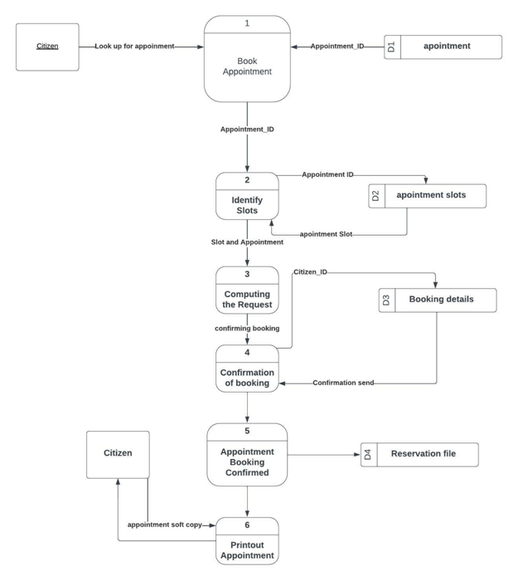

Physical Data Flow Diagram of Citizen canceling a reservation –

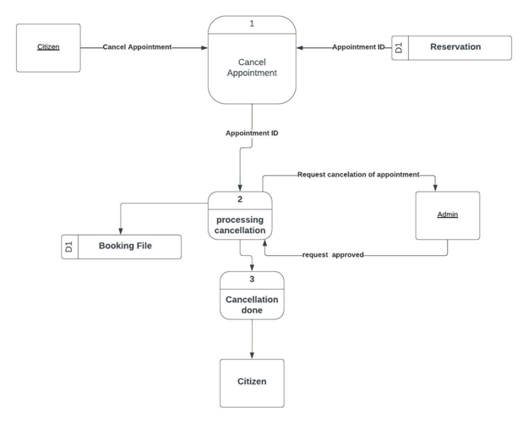

19. Activity diagrams

Activity diagram of Citizen booking an appointment-

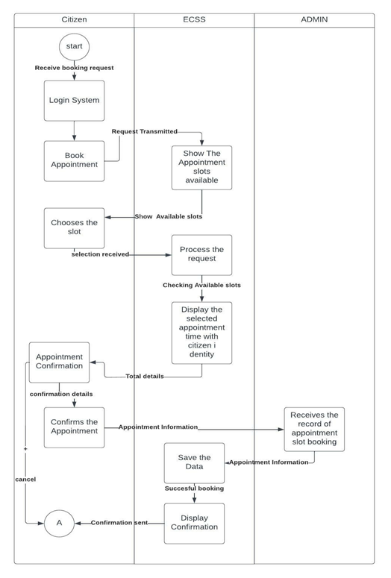

Activity diagram of Citizen canceling an appointment-

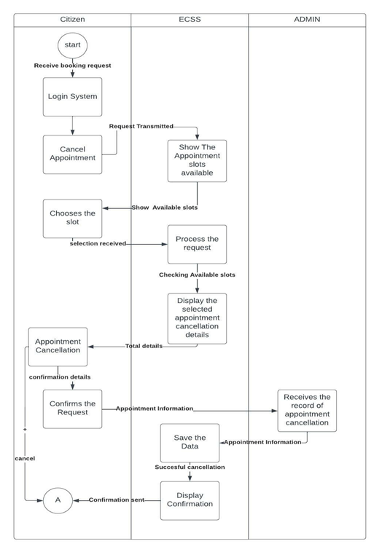

20. Sequence diagrams

Sequence Diagram of Citizen booking an Appointment

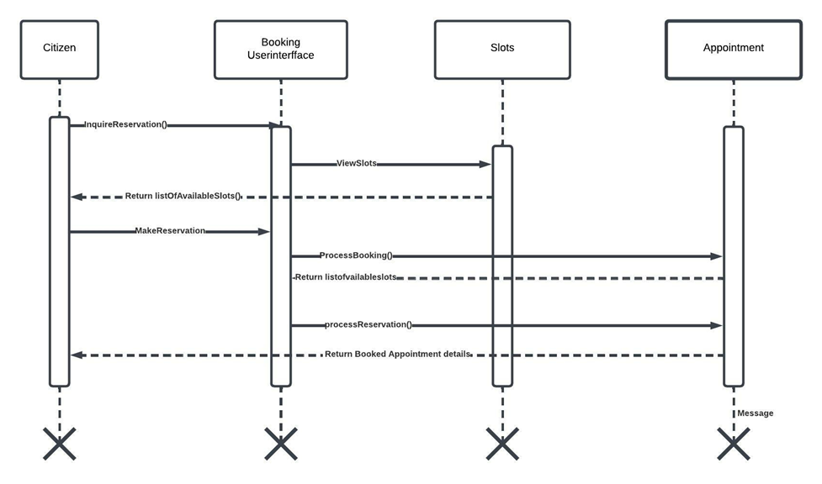

21. Communication diagrams

Communication of Citizen booking an Appointment

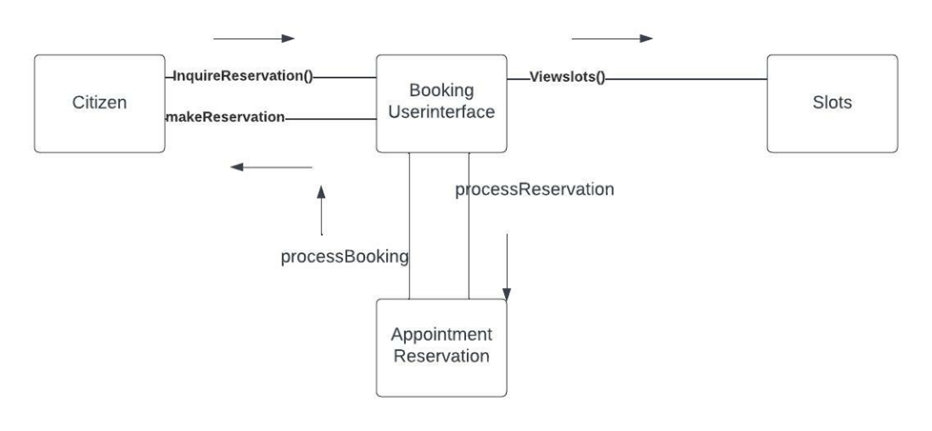

22. Class diagrams

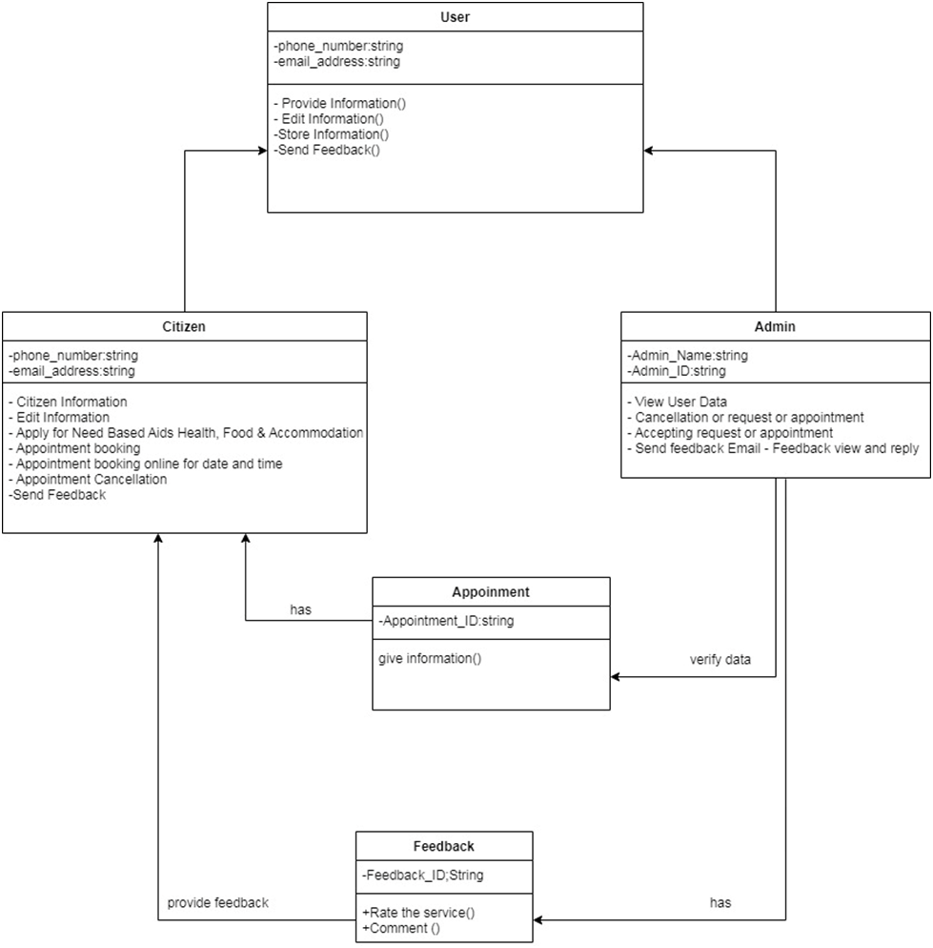

23. State-chart diagrams.

State chart Diagram of Appointment object

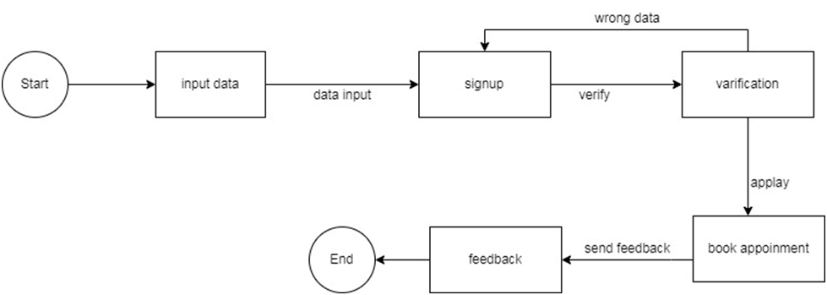

24. CRUD matrix

State chart Diagram of Citizen object-

|  |  |  |  |
| --- | --- | --- | --- |
| **Activity** | **citizen** | **Admin** | **Feedback Report** |
| **Register** | **C** |  |  |
| **Login** | **C** | **R** |  |
| **Edit Info** | **C** | **R** |  |
| **Apply for Need Based Aids Health, Food & Accommodation** | **C** | **R** |  |
| **book appointment** |  | **U** | **C** |
| **Give**  **Feedback** | **C** |  | **U** |
| **Delete**  **Report** |  |  | **D** |

**Section 5:**

25. Structure English pseudo code for the system

**Login to the Profile**

Do provide user’s information

IF User information is wrong

DISPLAY not matched

IF User information is right

DISPLAY User profile

END DO

**APPOINTMENT**

Do provide user’s information

IF User information is right

DISPLAY User profile

THEN go to the appointment page

DO select the time and date

THEN get feedback from the admin

ELSE show error

ENDIF

**NEEDBASED APPLICATION**

Do provide user’s information

IF User information is right

DISPLAY User profile

THEN go to the application page

DO fill up the information as required

IF the information is valid

THEN get feedback from the admin

ELSE show error

ENDIF

**Give feedback**

Login to the System

IF login done successfully

DO While user is logged into the system

IF application is done

THEN

DISPLAY feedback form for the user

DISPLAY Feedback recorded

END IF

ELSE

Show error

END DO

26. Prototype the user interface

